UNITED STATES

SECURITIES AND EXCHANGE COMMISSION

WASHINGTON, D.C. 20549

FORM 6-K

REPORT OF FOREIGN PRIVATE ISSUER

PURSUANT TO RULE 13a-16 OR 15d-16 UNDER

THE SECURITIES EXCHANGE ACT OF 1934

For the month of May 2026

Commission File Number: 001-41611

Hesai Group

10th Floor, Building A

No. 658 Zhaohua Road, Changning District

Shanghai 200050

People’s Republic of China

(Address of principal executive offices)

Indicate by check mark whether the registrant files or will file annual reports under cover of Form 20-F or Form 40-F.

Form 20-F ☒ Form 40-F ☐

Exhibit Index

99.1 Monthly Return of Equity Issuer on Movements in Securities for the month ended 30 April 2026

99.2 Announcement—Record Date for 2026 Annual General Meeting

SIGNATURES

Pursuant to the requirements of the Securities Exchange Act of 1934, the registrant has duly caused this report to be signed on its behalf by the undersigned, thereunto duly authorized.

Hesai Group
By | : | /s/ Yifan Li
Name | : | Yifan Li
Title | : | Chief Executive Officer

Date: May 8, 2026

Exhibit 99.1
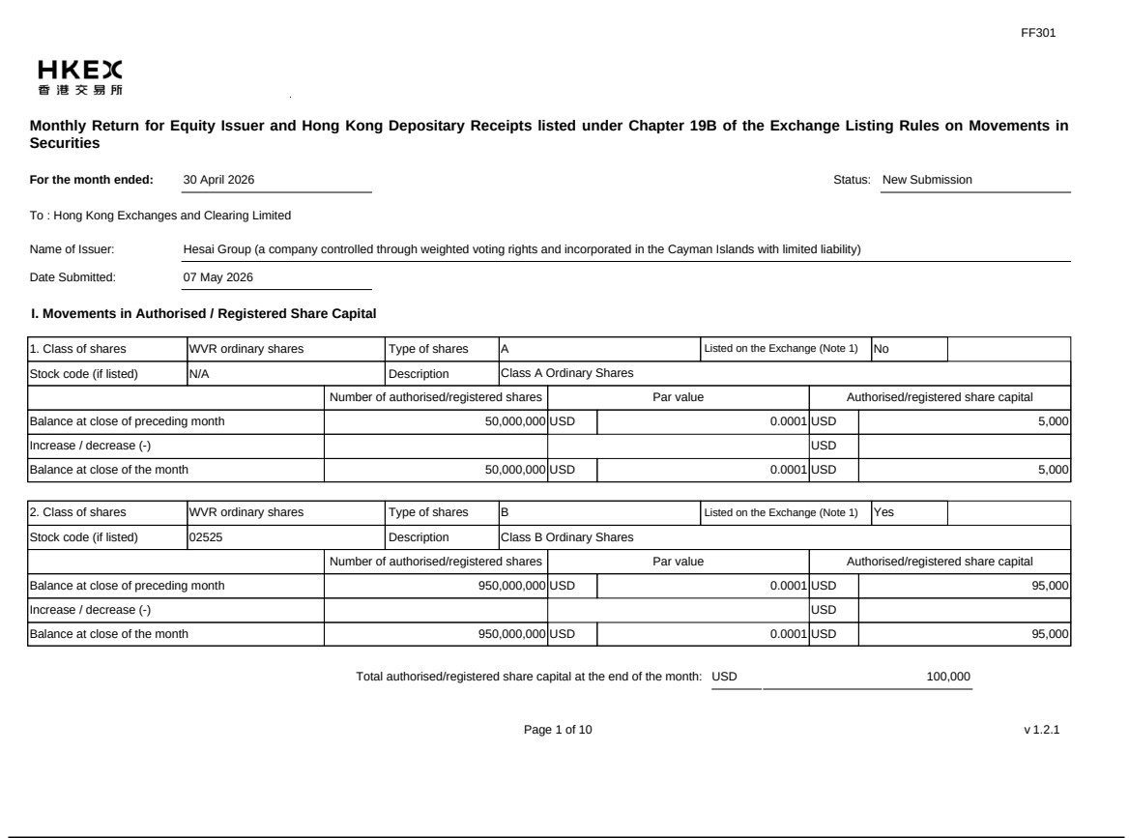

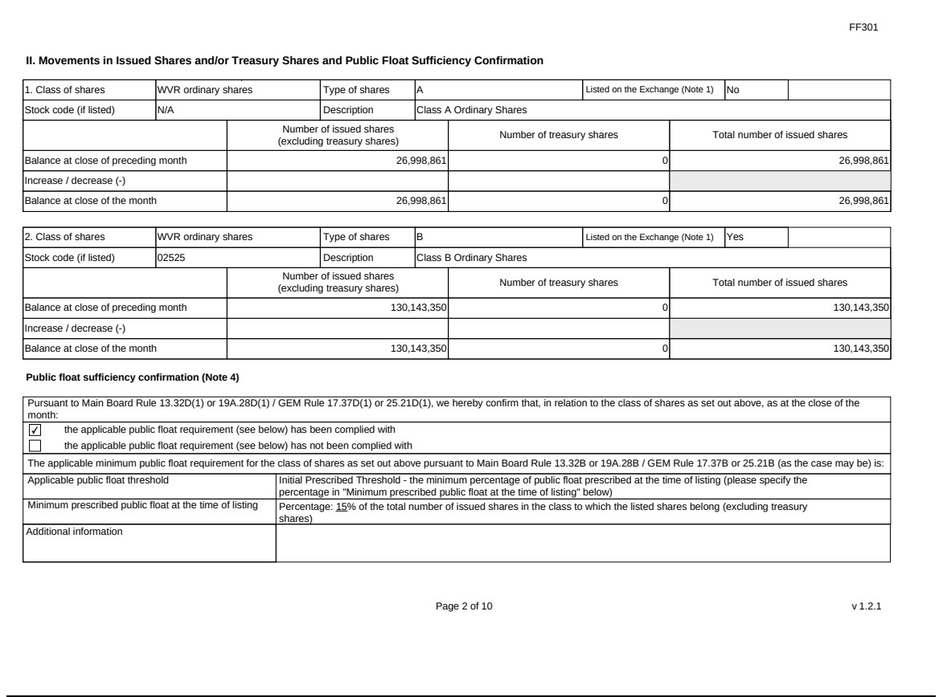

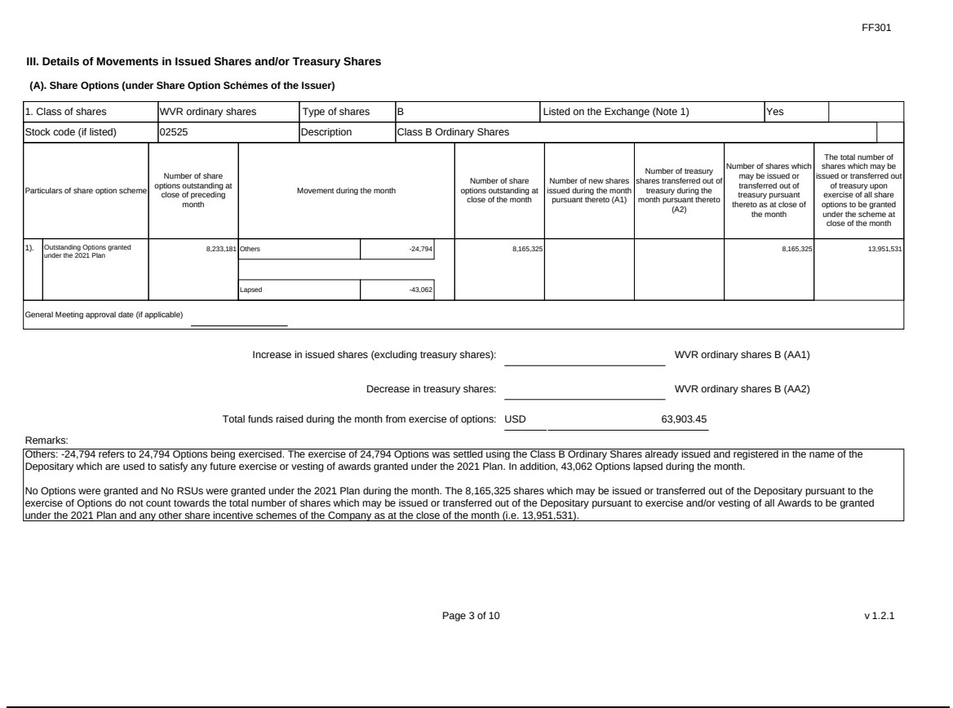





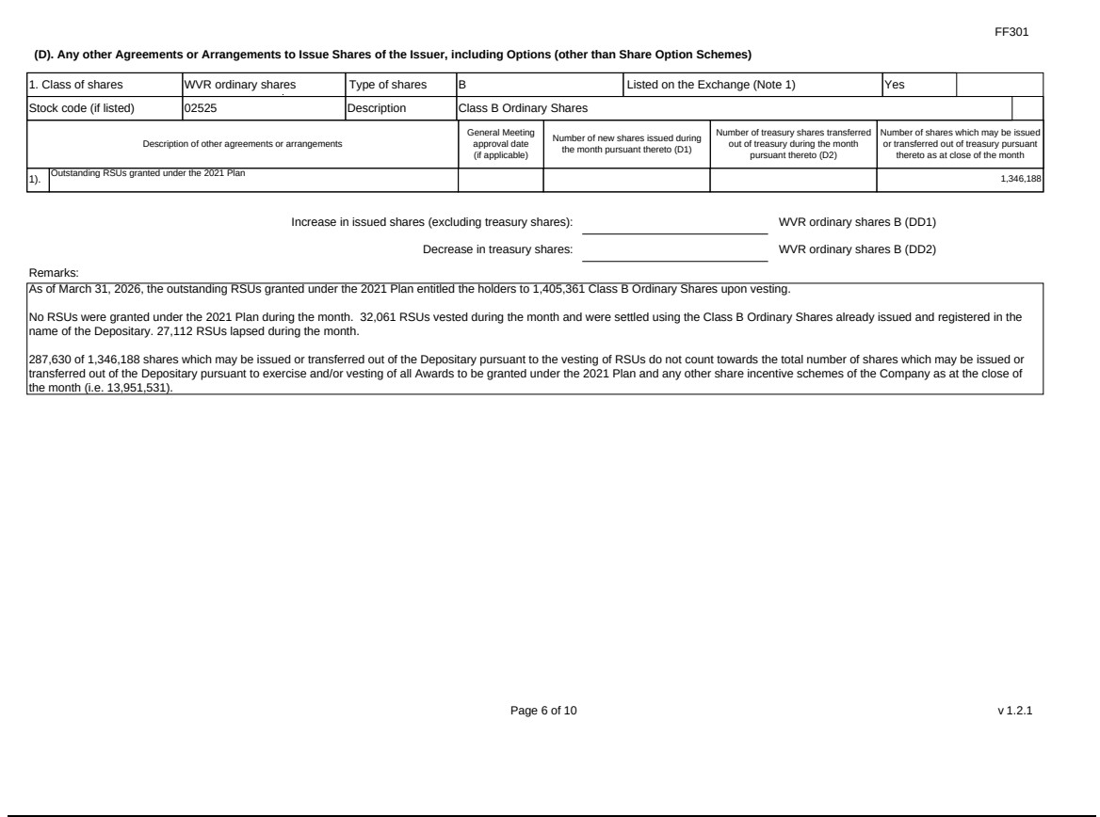

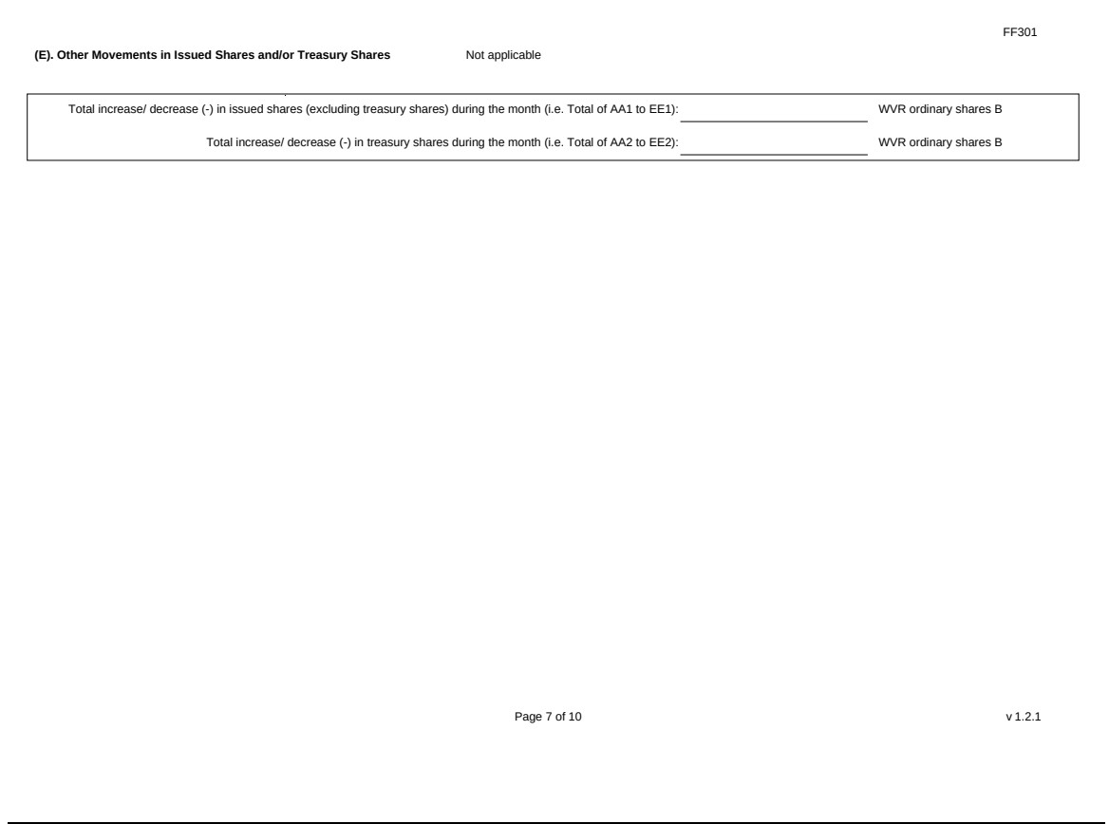

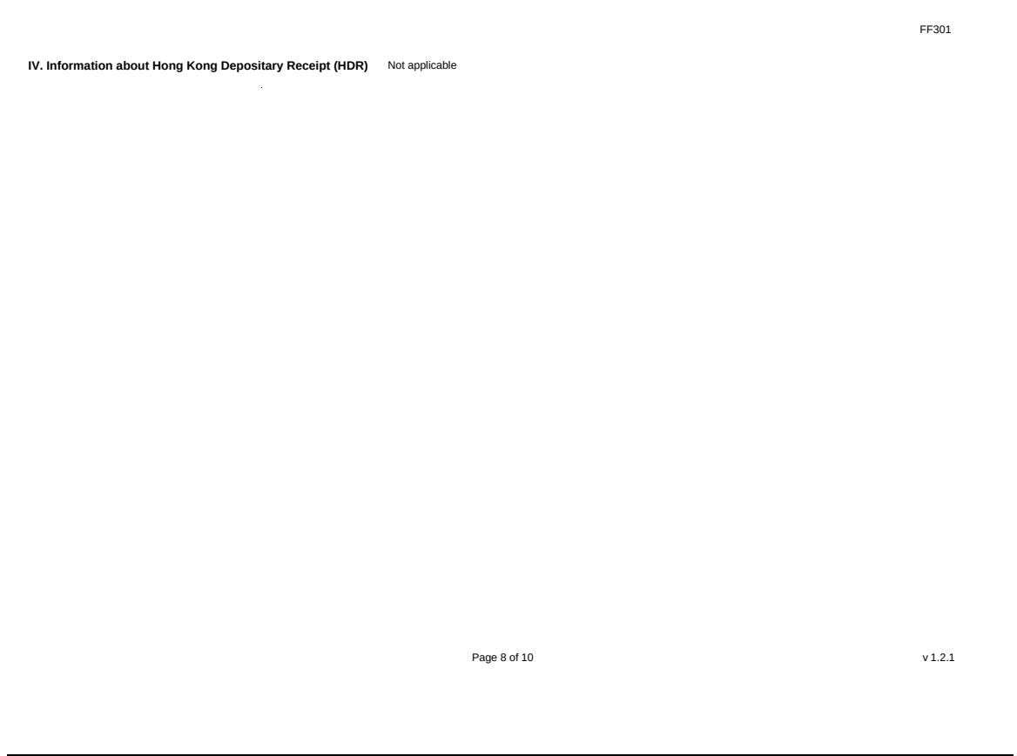

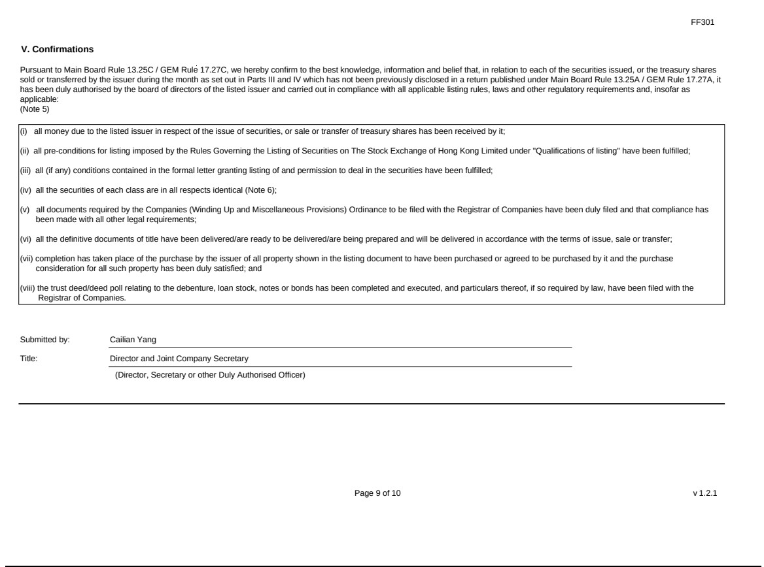

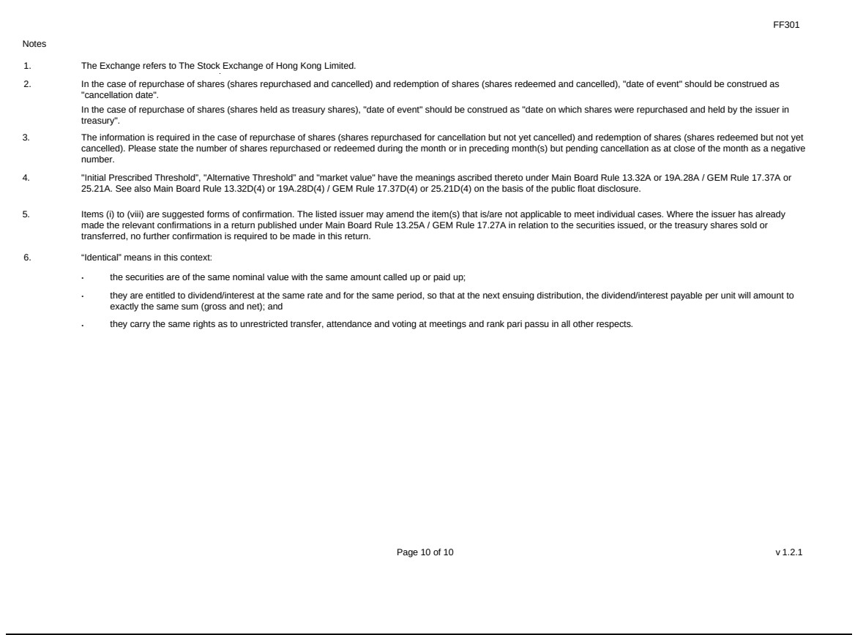

Exhibit 99.2

Hong Kong Exchanges and Clearing Limited and The Stock Exchange of Hong Kong Limited take no responsibility for the contents of this announcement, make no representation as to its accuracy or completeness and expressly disclaim any liability whatsoever for any loss howsoever arising from or in reliance upon the whole or any part of the contents of this announcement.


Hesai Group

禾 賽 科 技 *

(A company controlled through weighted voting rights and incorporated in the Cayman Islands with limited liability)

(HKEX Stock Code: 2525)

(NASDAQ Stock Ticker: HSAI)

RECORD DATE FOR 2026 ANNUAL GENERAL MEETING

The annual general meeting (the “AGM”) of Hesai Group (the “Company”) is scheduled to be held on Friday, June 26, 2026, Hong Kong time.

The board of directors of the Company (the “Board”) announces that the record date for the purpose of determining the eligibility of the holders of the Class A ordinary shares and/or Class B ordinary shares of the Company, each with a par value US$0.0001 per share, to attend and vote at the forthcoming AGM will be as of the close of business on Friday, May 22, 2026, Hong Kong time (the “Shares Record Date”). Holders of the Company’s Class A ordinary shares and/or Class B ordinary shares as of the Shares Record Date are entitled to attend and vote at the forthcoming AGM and any adjourned meeting thereof.

In order to be eligible to attend and vote at the AGM, persons who hold the Company’s Class A ordinary shares and/or Class B ordinary shares directly on our Cayman Islands register of members should ensure that all valid transfer documents, accompanied by the relevant share certificates, are lodged with our principal share registrar in Cayman Islands, Maples Fund Services (Cayman) Limited, at PO Box 1093, Boundary Hall, Cricket Square, Grand Cayman, KY1-1102, Cayman Islands, before 4:30 p.m., Cayman Islands time, on Thursday, May 21, 2026 (due to the time difference between Cayman Islands and Hong Kong); and persons who hold the Company’s Class B ordinary shares directly on our Hong Kong register of members should ensure that all valid transfer documents, accompanied by the relevant share certificates, are lodged with our branch share registrar in Hong Kong, Tricor Investor Services Limited, at 17/F, Far East Finance Centre, 16 Harcourt Road, Hong Kong, before 4:30 p.m., on Friday, May 22, 2026, Hong Kong time.

Holders of record of American Depositary Shares, each representing one Class B ordinary shares of the Company (the “ADSs”) as of the close of business on Friday May 22, 2026, New York time (the “ADS Record Date”) who wish to exercise their voting rights for the underlying Class B ordinary shares must give voting instructions to Deutsche Bank Trust Company Americas, the depositary of the ADSs (the “Depositary”). Please be aware that, because of the time difference between Hong Kong and New York, any ADS holders that cancel their ADSs in exchange for Class B ordinary shares on Friday, May 22, 2026, New York time will no longer be ADS holders with respect to such cancelled ADSs as of the ADS Record Date and will not be able to instruct the Depositary as to how to vote the Class B ordinary shares represented by such cancelled ADSs as described above; such ADS holders will also not be holders of the Class B ordinary shares represented by such cancelled ADSs as of the Shares Record Date for the purpose of determining the eligibility to attend and vote at the AGM.

1

Details including the meeting date and location of the AGM will be set out in the circular and the notice of such meeting to be issued by the Company in due course.

By order of the Board

Hesai Group

Dr. Yifan Li

Chairman of the Board, Executive Director and

Chief Executive Officer

Hong Kong, May 8, 2026

As at the date of this announcement, the Board comprises: (i) Dr. Yifan Li, Dr. Kai Sun, Mr. Shaoqing Xiang and Ms. Cailian Yang as the executive Directors; and (ii) Ms. Yi Zhang, Mr. Jia Ren and Dr. Hui Wang as the independent non-executive Directors.

- For identification purpose only

2

